IMAGINE 2020 (2.0) – ART, ECOLOGY AND POSSIBLE FUTURES

SUMMER LAB #1 – TOXIC TOUR

29 – 31 AUGUST / LJUBLJANA; LJUBLJANSKO BARJE (Ljubljana Marsh Nature Park)

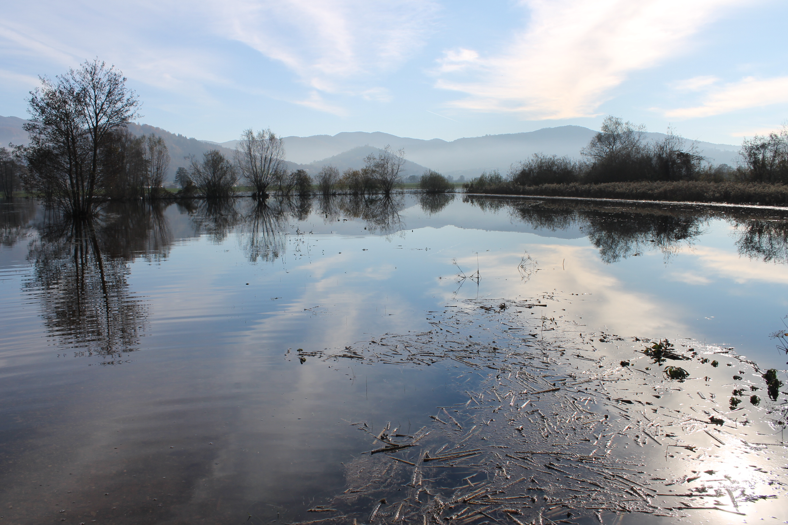
foto: Maša Bratina

GENERAL THEMES and CONTENT

The participants will focus on the changing inter-relations and co-relations that the increasing pollution imposes on the fragile equilibrium of the ecosystem Ljubljansko barje (Ljubljana Marsh Nature Park), by observing and giving voices to its non-human dwellers whose languages we don’t speak and are only capable to imagine - water (rivers, sources, undercurrents), plants (invasive and autochthone plants), animals (birds, boars, frogs, mosquitos) - and the entities like geological time, micro-climate and specific geography (physical, sonic, etc) of the location. We will follow the logic of the so-called toxic tours, that don’t only educate their visitors but also can engage in a discussion and even decision-making process of the parties involved in a situation of direct pollution.

While toxic tourism, as an offspring of eco-tourism and its call for responsible traveling to natural reserves, calls for visits to poorest neighbourhoods in urban areas and creates dialogue about environmental racism, we will employ some of its features for this specific workshop: some of the experts or engaged citizens that we will meet are part of the local

health-related organisations and communities that live in the area. Thus the act of listening will be even more important than just “giving voices to".

Toxic tours are also tools for collaborative imagining of solutions and active intervening into a situation of pollution. One of the goals of the workshop would be to design manifesto/manifestoes that aim at creatively raising attention of the increasingly worrying situation at Ljubljansko barje due to pesticides. Another goal is to get inspired and empowered by the beauty of the natural site and the actions local inhabitants - human and non-human - make to keep it in balance.

The three days lab will consist of guided toxic tours on Ljubljansko barje in the south of Ljubljana, we will be walking around marshes, biking or taking small boats on the river, stopping to observe, discuss and have picnics. In the evenings we will return to town and exchange thoughts, practices and possibly engage in designing manifesto. The group of participants is limited to approximately 20 people, but we could imagine opening it up in a more public discussion the last day.

We look for artists and practitioners who in their practices address the issues of toxicity (in its more vast social, gendered, political meaning), reflect on the concepts of the so-called era of Anthropocene and its abolition of division between nature and culture, research human/non-human interactions and co-living, are interested in the legal rights of nature.

The Summer Lab will be moderated by Nataša Petrešin Bachelez (independent curator, writer and editor), names of other speakers and mentors (ornithologist, water supply and cleaning specialist, biologist, local artists and activists) as well as more precise program outline will be given later.

PRATICAL INFORMATION

Date
Monday 29 August – 31 August 2016
Location
Ljubljana, Ljubljansko barje http://www.ljubljanskobarje.si/en/ljubljana-moors/the-ljubljana-moors
http://www.ljubljanskobarje.si/?lang=en
https://www.visitljubljana.com/en/visitors/poigroup/nature-and-active-holidays/ljubljana-marshes/
Accommodation
Hotel Park http://www.hotelpark.si/?sLang=en
Bunker is covering accommodation costs from 28 August to 1 September.
Catering
Bunker will provide lunch and dinner, breakfast is provided in the hotel. Please let us know in advance about any dietary requirements or other allergies so we can make arrangements.
Travel and arrival/departure arrangements

Imagine 2020 partners should cover the travel costs for their invited participants. The participants should arrive on 28 August (preferably before the evening, as the network members would like to meet them) and depart on 1st September.
Bunker can help with finding good travel connections to Ljubljana.
Mladi levi festival and Ready to Change conference
Mladi levi festival is taking place from 19 to 28 August. The program is not confirmed yet, but there will be some projects within Imagine 2020 framework (http://www.bunker.si/eng/festivals/mladi-levi).
Part of the festival will be also Ready to Change conference from 26 to 27 August (working title New narratives / New political mythologies) with key note speakers Tony Chakar (architect and writer from Beirut) and Mitja Velikonja (Chair of Cultural Studies at the Centre for Cultural and Religious Studies at the University of Ljubljana).
If any of the participants would like to attend the festival and the conference too, we can take care of hotel reservation and tickets booking.
Deadline
Please, let us know about the participants by the June 20th.
Other
Since most of the workshops and sessions will take place outdoors, please bring adequate clothing. Also comfortable footwear is recommended, since walking sessions are planned.
Contacts
Maja Vižin maja.vizin@bunker.si, +386 31 326099
Nevenka Koprivšek nevenka.koprivsek@bunker.si

